REPORT FORMAT-A
Report of “दिल्ली को कूड़े से आज़ादी – Swacchata Campaign”
Conducted from 01.08.2025 – 31.08.2025
Name of the Institution
Janakpuri Super Specialty Hospital

Date
01.08.2025
Swacchata Pledge and Shramdan
Activity conducted –
The Swacchata Drive has been started at Janakpuri Super Speciality Hospital on 01.08.2025 after taking the Pledge by all the employees of the hospital. Following that the employees moves towards the backside of the hospital building to clean the peripheral roads. Hence the employee of JSSH are committed for the swacchata abhiyan and ready for the shramdan.

Details (50-100 words) –

Pledge
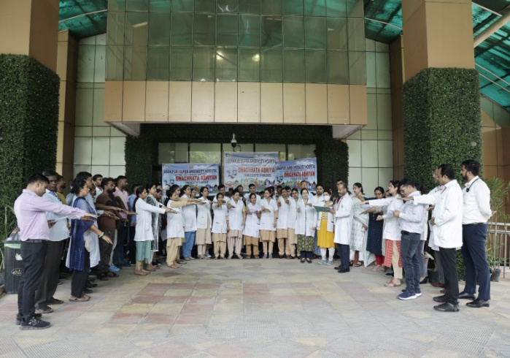 | 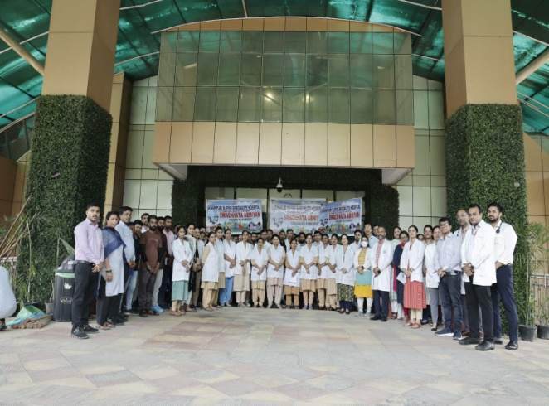
Shramdan
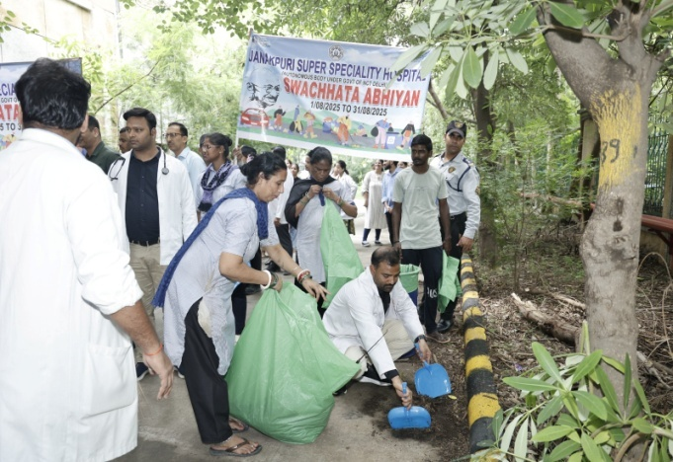 | 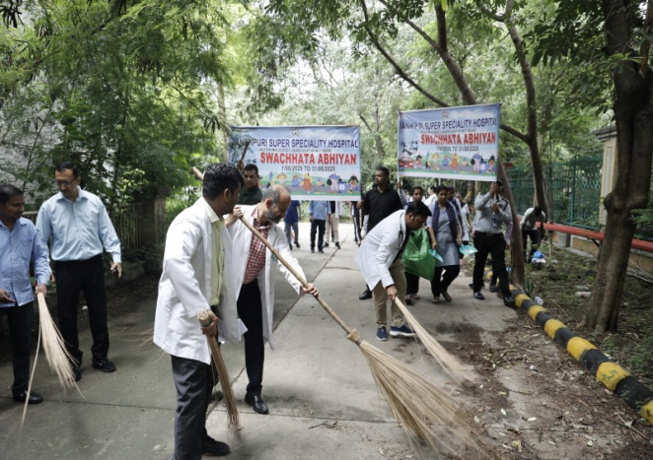
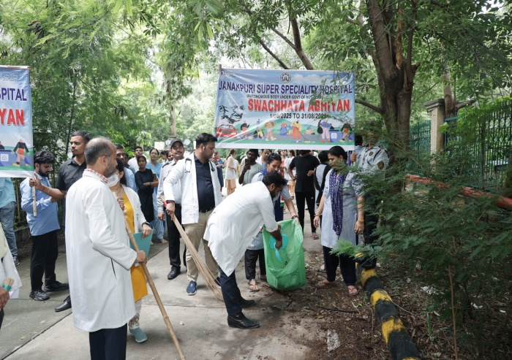 | 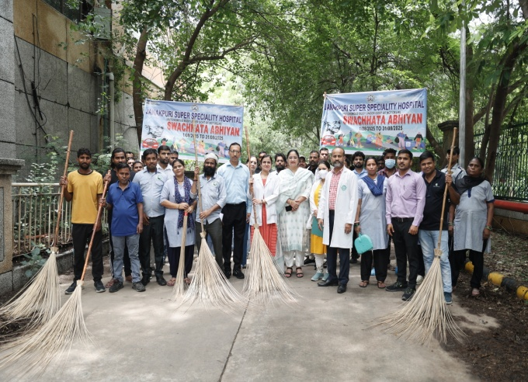

Before | After
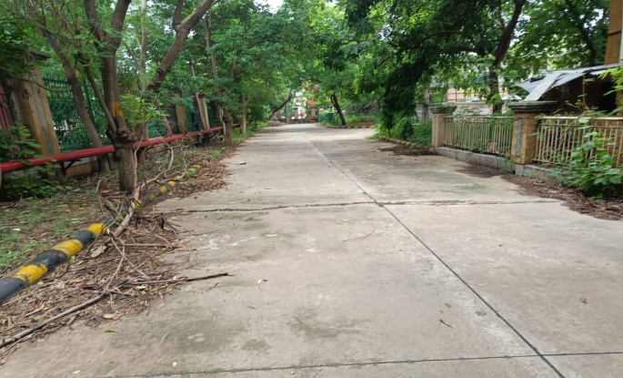 | 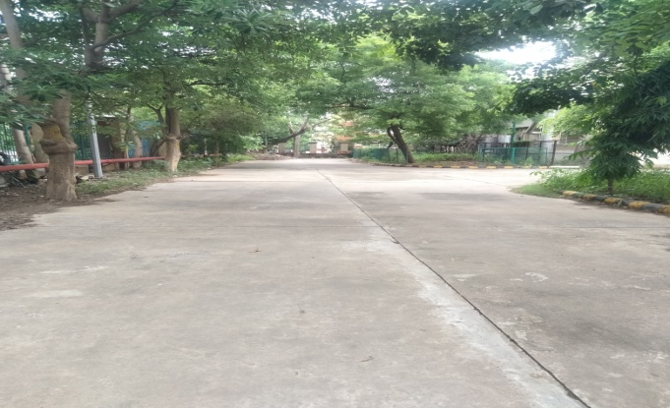
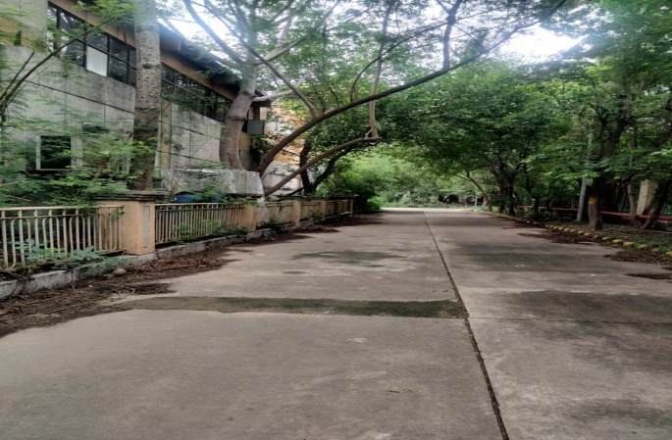 | 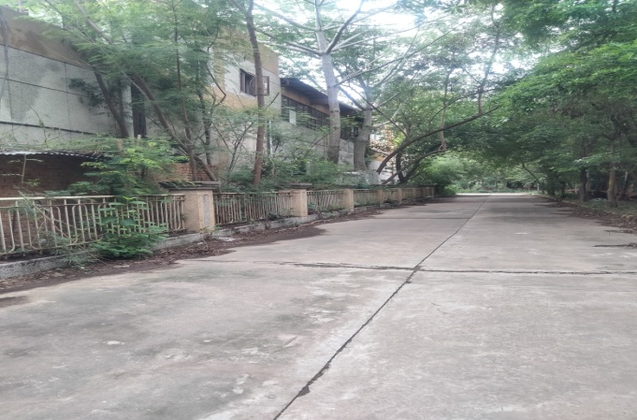

Remarks – Photograph of the activity should also be labeled for identification of activity.

Dr. Shiv Shankar Prasad Singh
Addl. M.S.
JSSH

