REPORT FORMAT-A
Report of “दिल्ली को कूड़े से आज़ादी – Swacchata Campaign”
Conducted from 01.08.2025 – 31.08.2025
Name of the Institution
Janakpuri Super Specialty Hospital
Date -
12.08.2025
Activity conducted –
Hold Internal Infection Control Meeting

The meeting of infections control committee was held in the board room as per the schedule. The relevant photos are enclosed herewith.
Details (50-100 words) –

Meeting
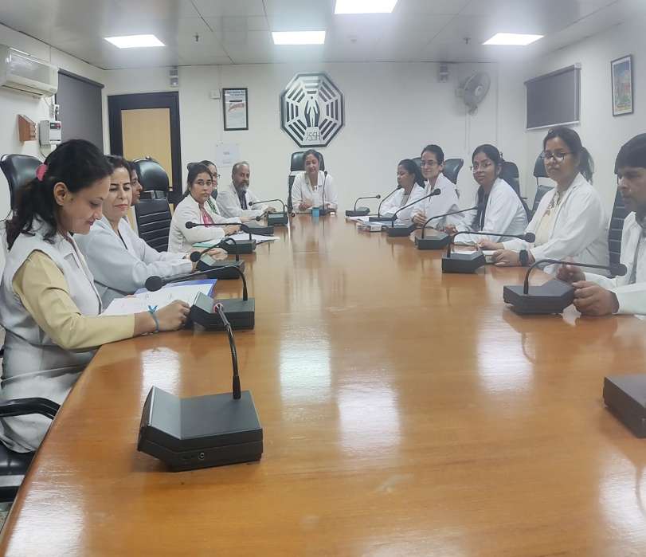 | 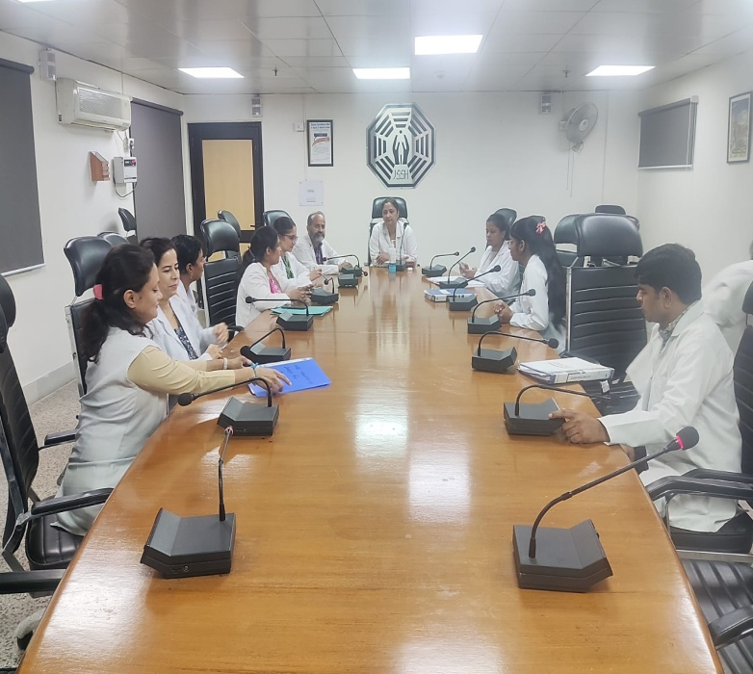
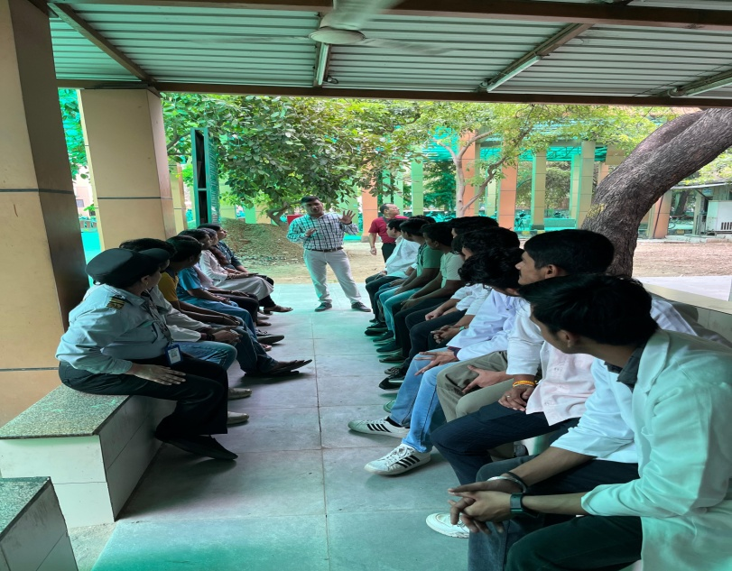 | 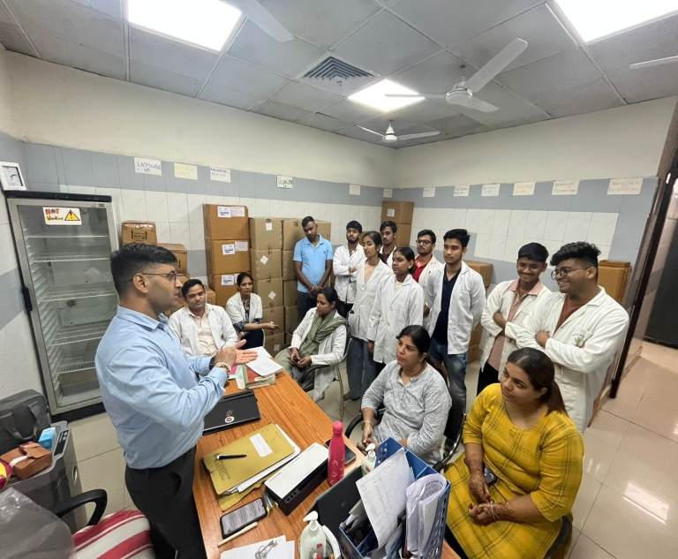

Remarks – Photograph of the activity should also be labeled for identification of activity. Dr. Shiv Shankar Prasad Singh
Addl. M.S.
JSSH

