REPORT FORMAT-A
Report of “दिल्ली को कूड़े से आज़ादी – Swacchata Campaign”
Conducted from 01.08.2025 – 31.08.2025
Name of the Institution
Janakpuri Super Specialty Hospital
Date -
13.08.2025
Activity conducted –
Outreach Vehicle Sanitation

Since there is no mobile van or ambulance available with the hospital. The swachhta drive was focused on to clean the basement area and rehabilitation department. The relevant photos are enclosed herewith.

Details (50-100 words) –

Before | After
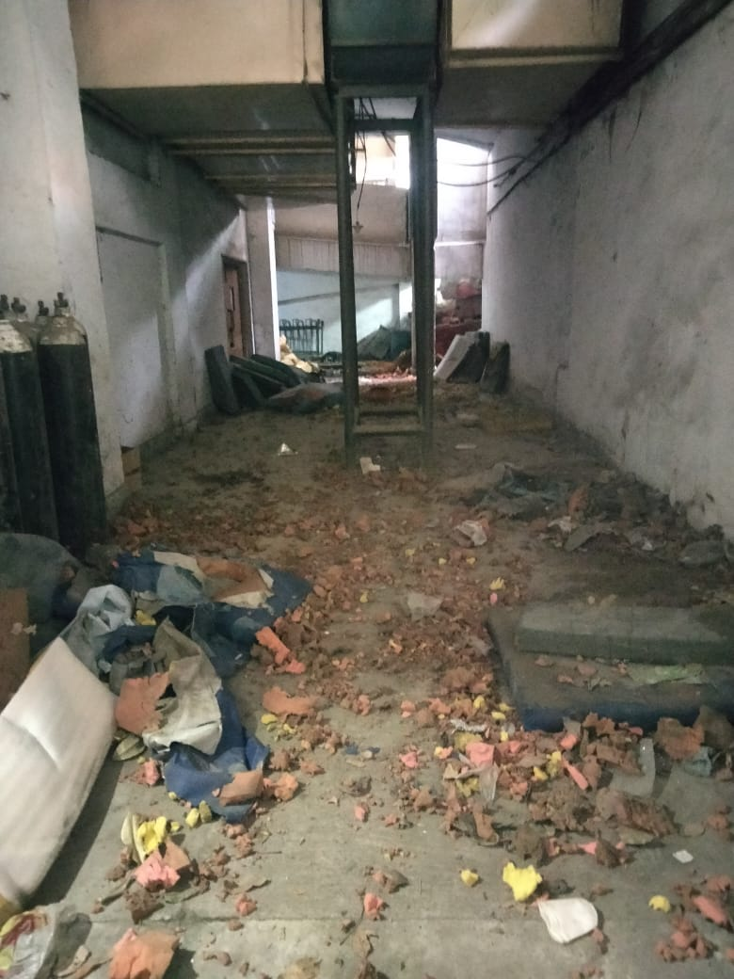 | 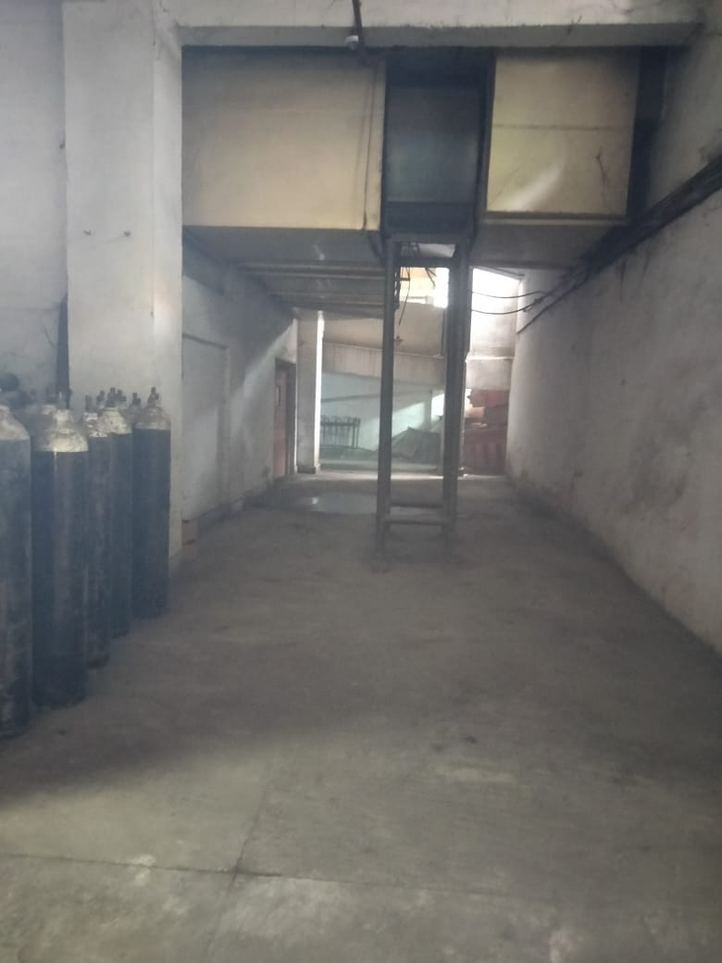
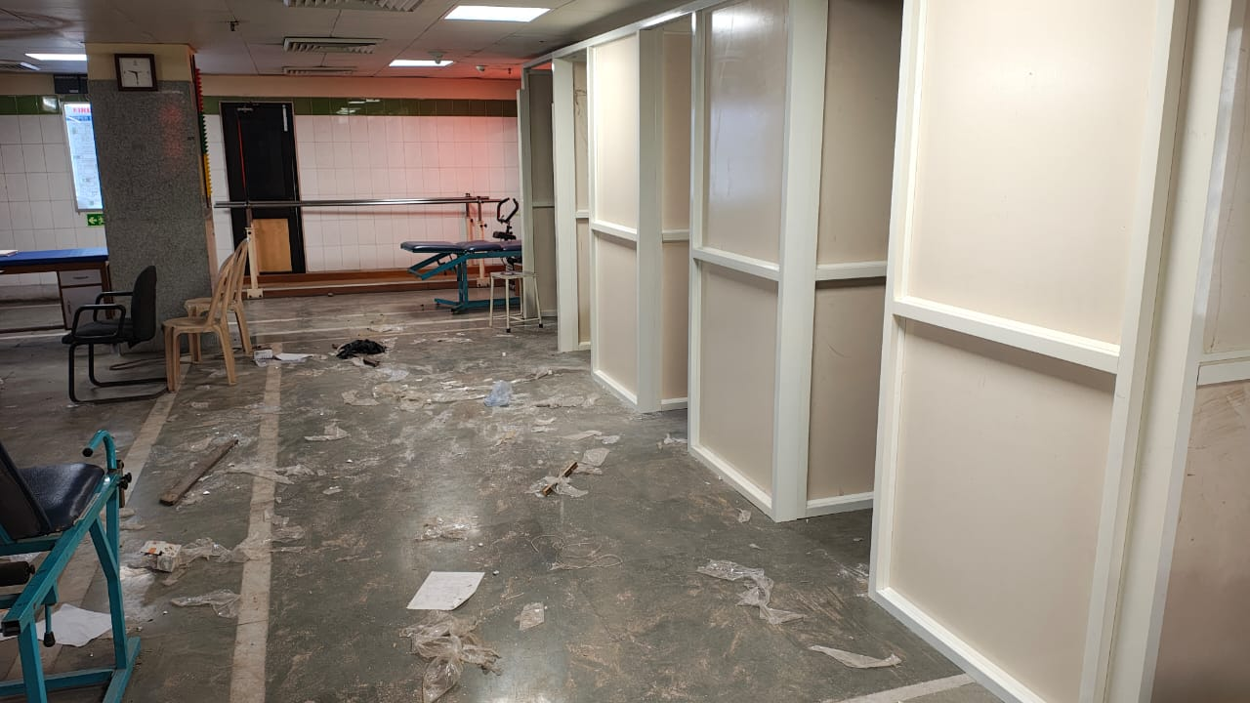 | 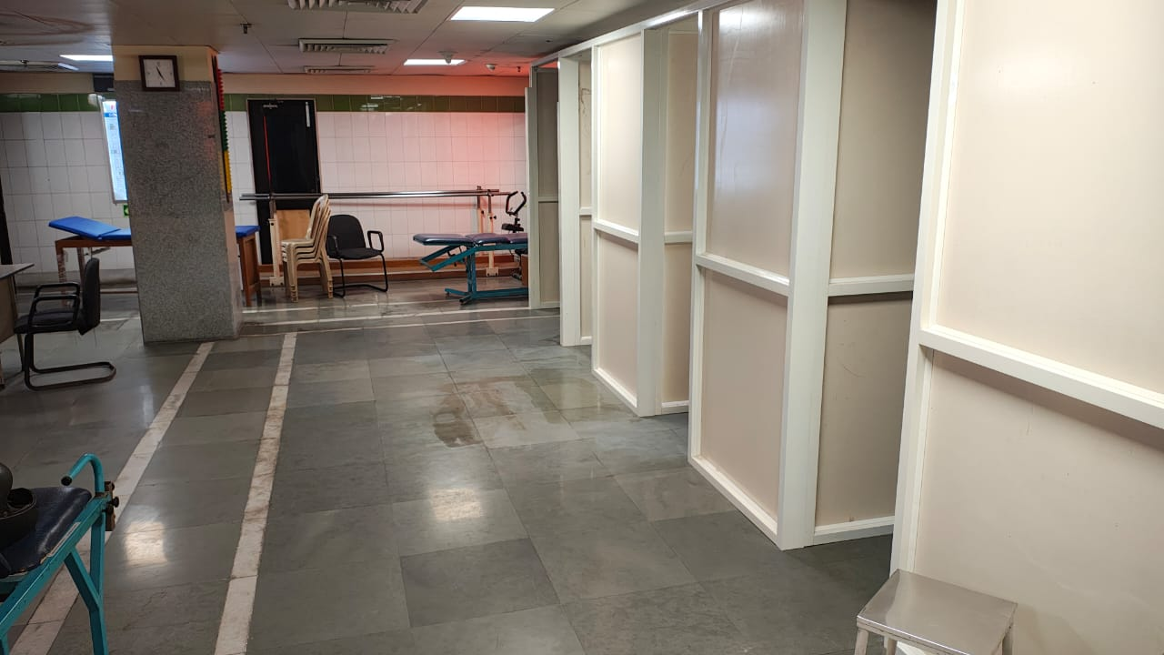

Remarks – Photograph of the activity should also be labeled for identification of activity. Dr. Shiv Shankar Prasad Singh
Addl. M.S.
JSSH

