REPORT FORMAT-A
Report of “दिल्ली को कूड़े से आज़ादी – Swacchata Campaign”
Conducted from 01.08.2025 – 31.08.2025
Name of the Institution
Janakpuri Super Specialty Hospital
Date -
14.08.2025
Activity conducted –
Patient Feedback on Cleanliness

Janakpuri Super Speciality hospital has a well established patient feedback mechanism both manually and online mode. A team of dedicated staff are working to collect the feedback and provide a ATR after consulting the higher authority. A public relation officer is deputed at the ground floor main entrance of hospital building to resolve the any grievance given by the patient on priority. The relevant photos are enclosed herewith.
Details (50-100 words) –

Photo with Patient | Feedback Form
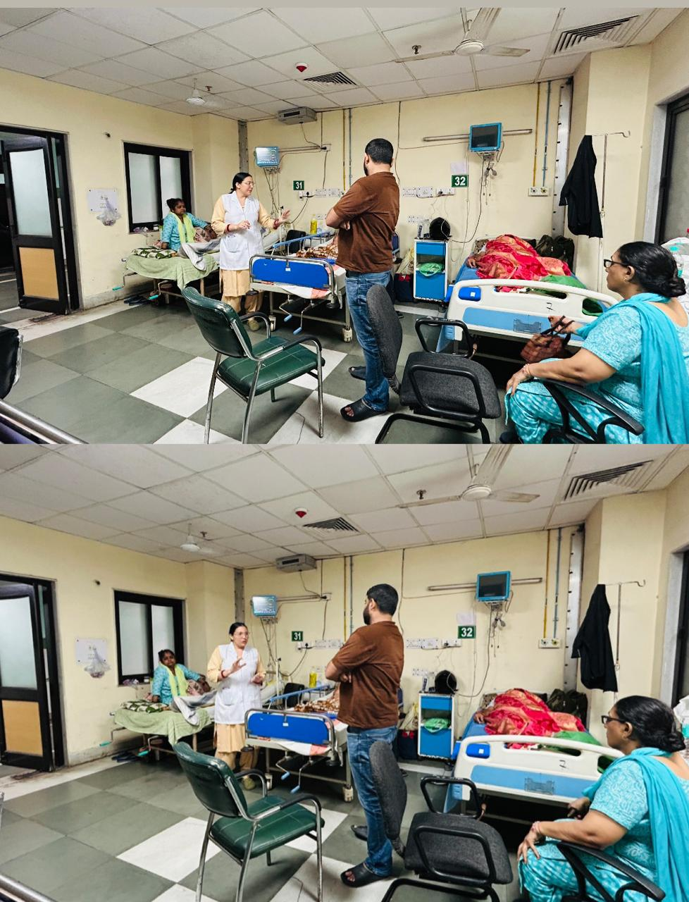 | 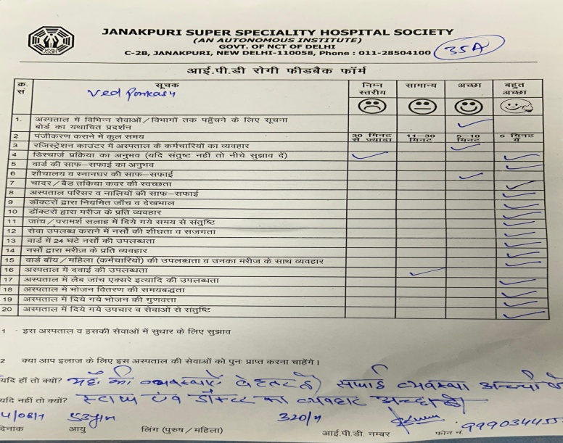
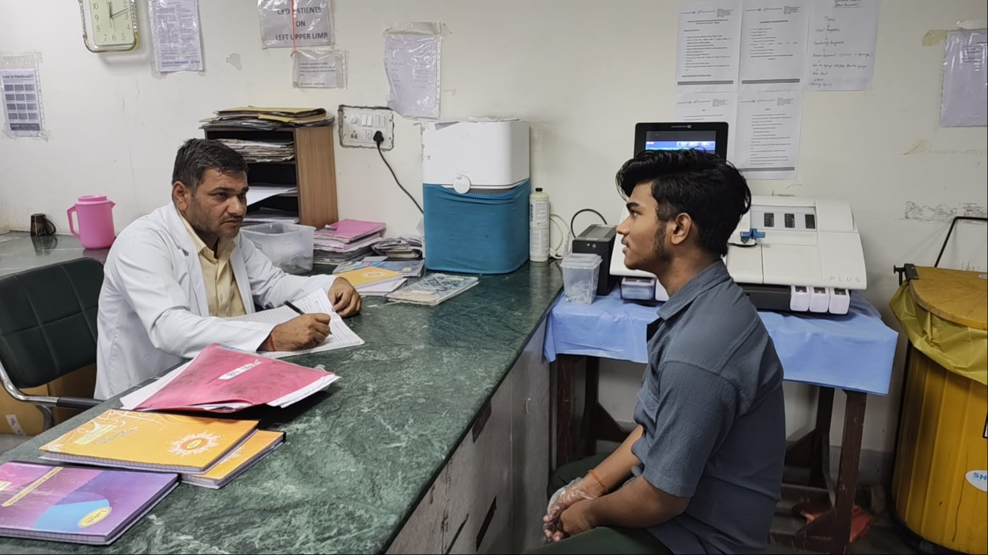 | 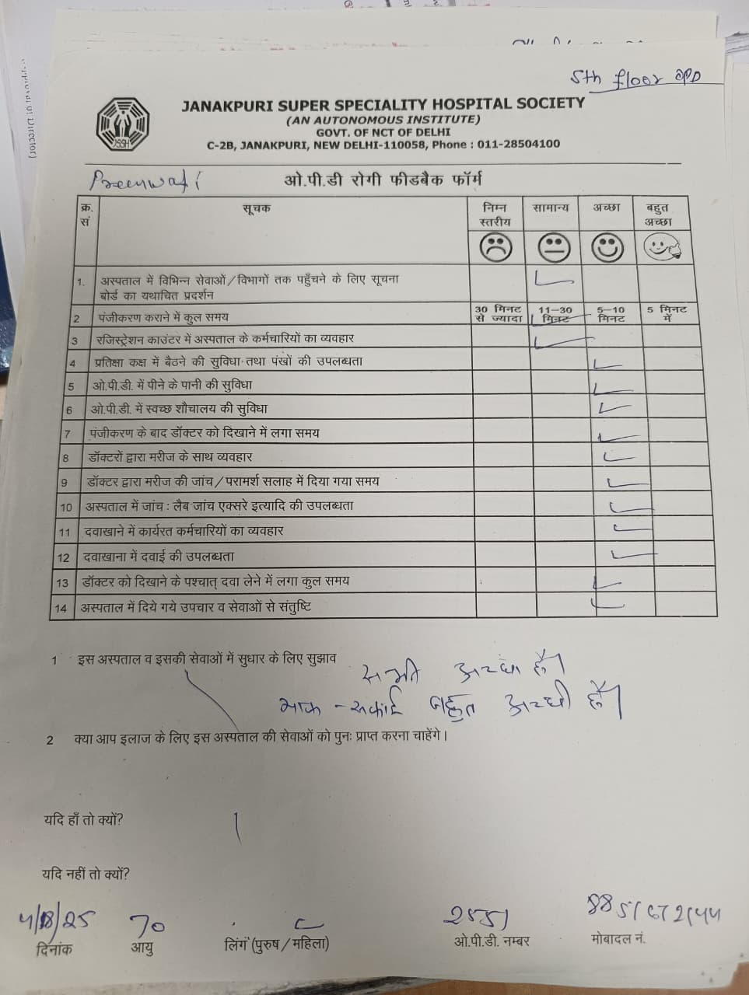
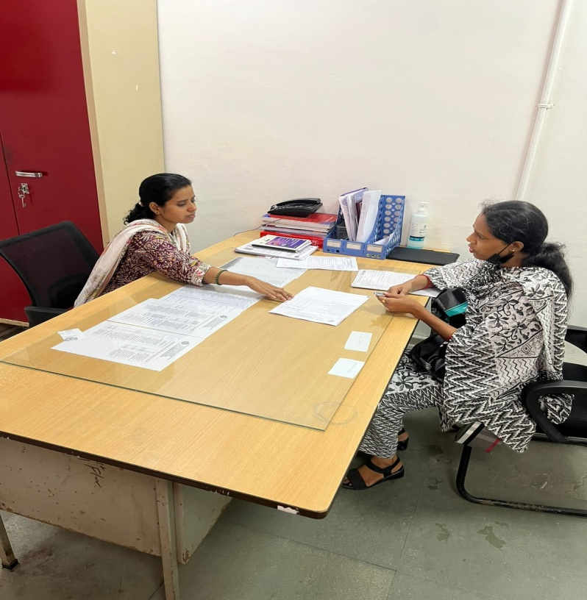 | 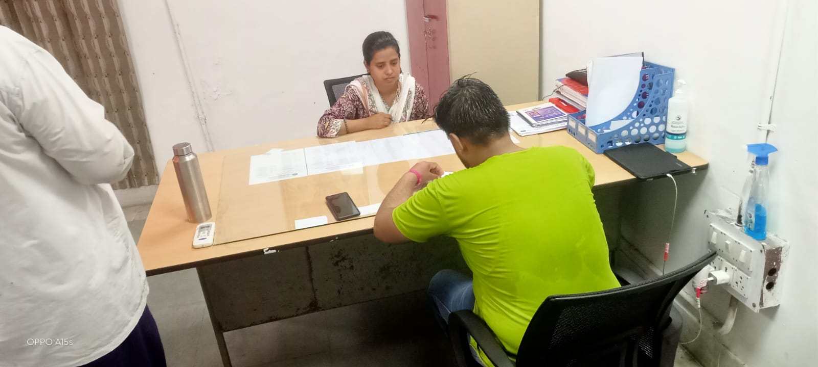

Remarks – Photograph of the activity should also be labeled for identification of activity. Dr. Shiv Shankar Prasad Singh
Addl. M.S.
JSSH

