REPORT FORMAT-A
Report of “दिल्ली को कूड़े से आज़ादी – Swacchata Campaign”
Conducted from 01.08.2025 – 31.08.2025
Name of the Institution
Janakpuri Super Specialty Hospital

Date
02.08.2025
Shramdan
Activity conducted –
As per the schedule enclosed a Shramdan activity was taken place in the public park in front of the gate no. 1 of the hospital building. The before and after photos of the same are enclosed herewith.

Details (50-100 words) –
Shramdan
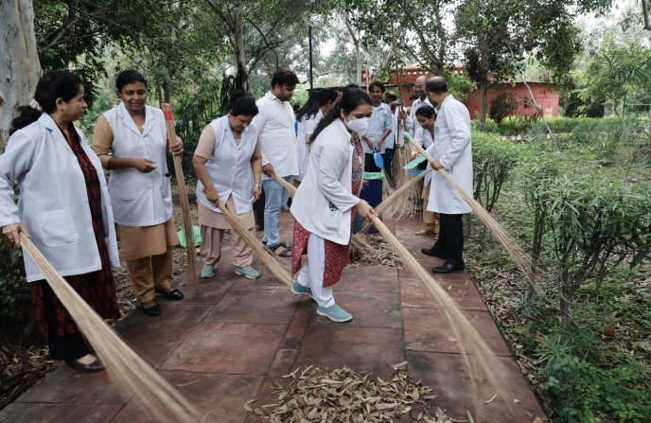 | 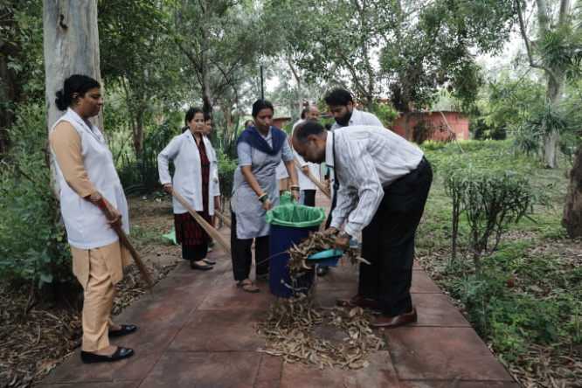
Before | After
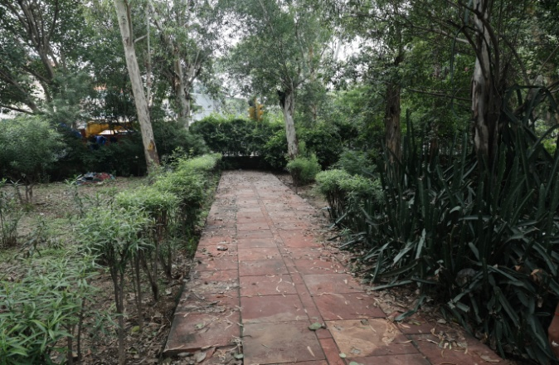 | 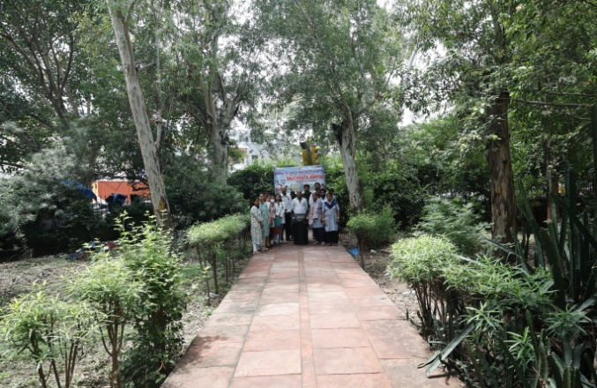

Remarks – Photograph of the activity should also be labeled for identification of activity.

Dr. Shiv Shankar Prasad Singh
Addl. M.S.
JSSH

