REPORT FORMAT-A
Report of “दिल्ली को कूड़े से आज़ादी – Swacchata Campaign”
Conducted from 01.08.2025 – 31.08.2025
Name of the Institution
Janakpuri Super Specialty Hospital
Date -
20.08.2025
Activity conducted –
Community Awareness on Hygiene

A wide spread awareness drive was conducted at the various department of the hospital to address the patients and their attendants regarding importance of hygiene in our day to day life. The relevant photos are enclosed herewith.
Details (50-100 words) –

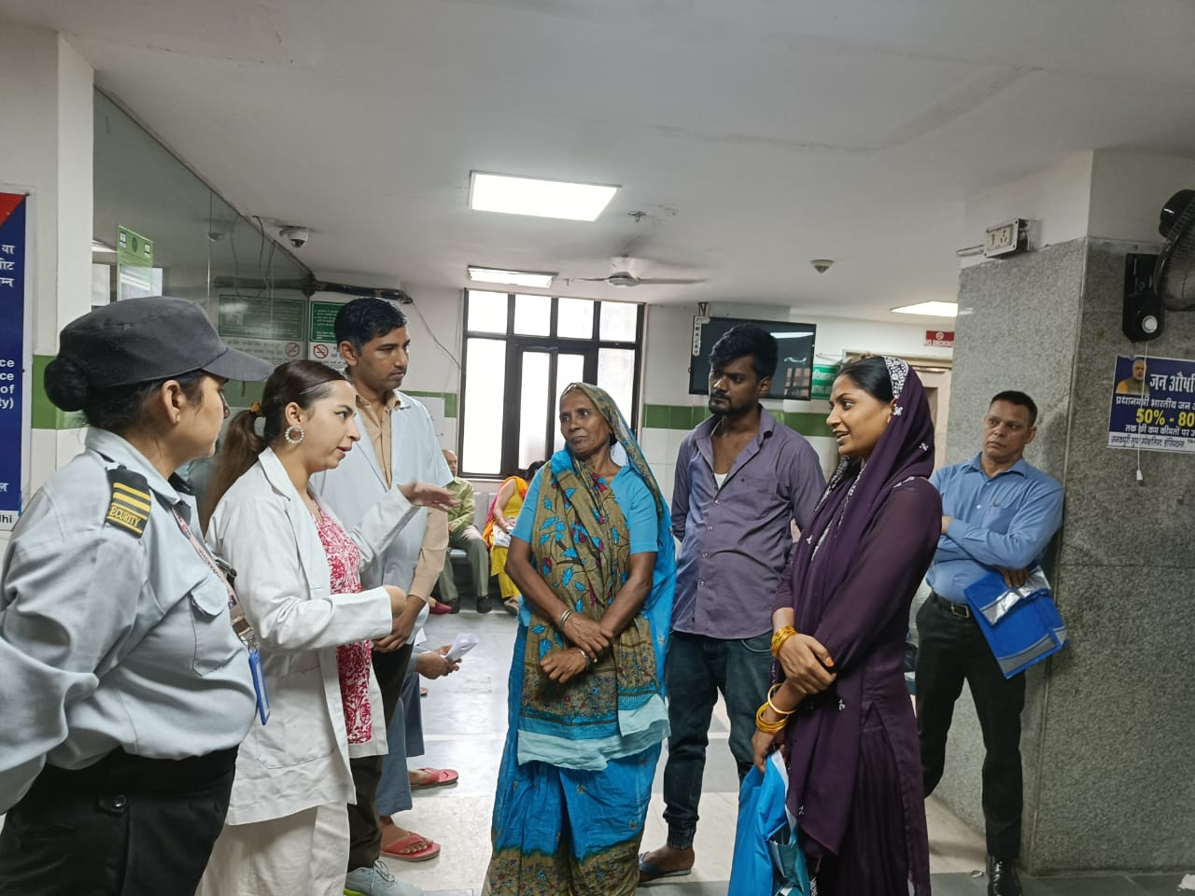 | 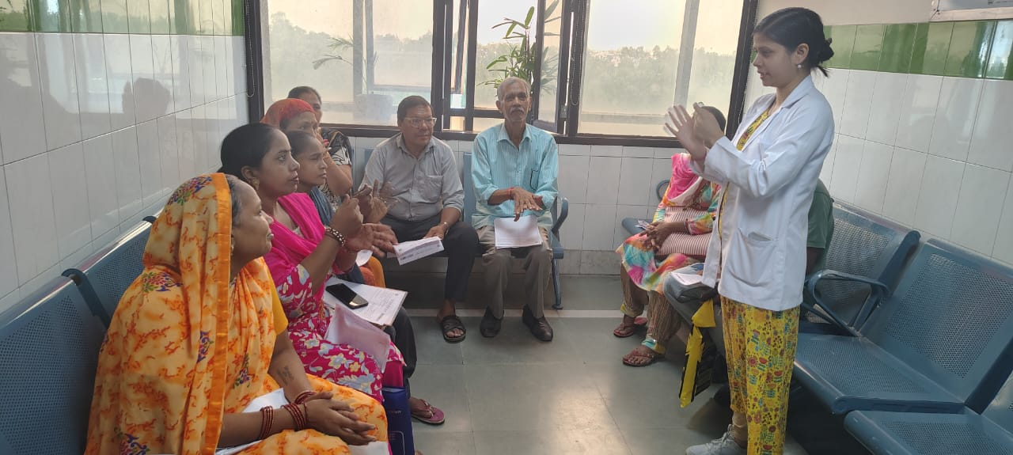
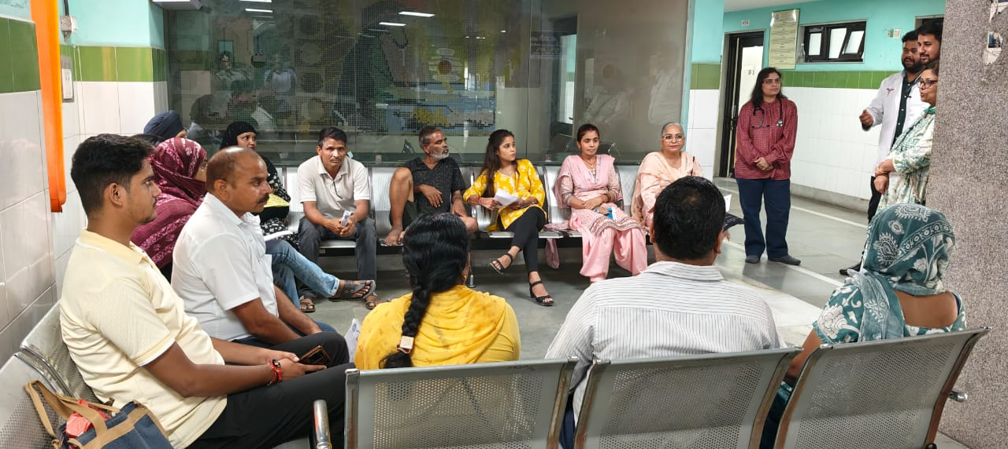 | 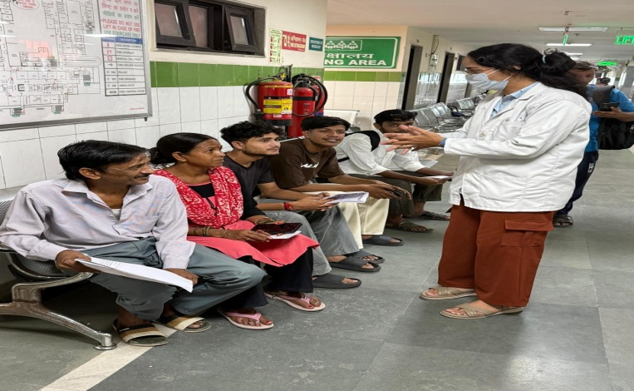
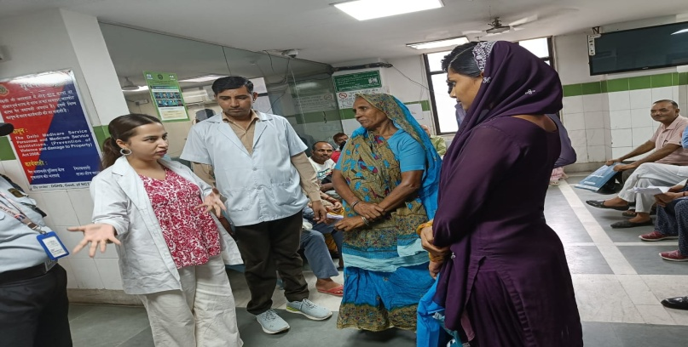 | 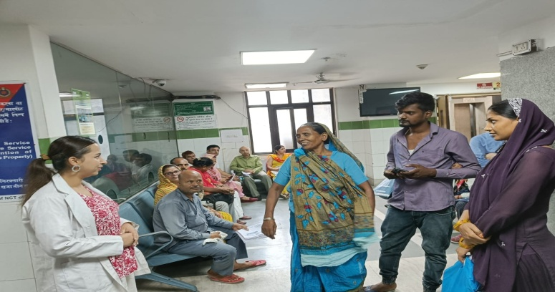

Remarks – Photograph of the activity should also be labeled for identification of activity. Dr. Shiv Shankar Prasad Singh
Addl. M.S.
JSSH

