REPORT FORMAT-A
Report of “दिल्ली को कूड़े से आज़ादी – Swacchata Campaign”
Conducted from 01.08.2025 – 31.08.2025
Name of the Institution
Janakpuri Super Specialty Hospital
Date -
23.08.2025
Activity conducted –
Shramdaan Day, Laundry & Line Audit and Shramdaan at outside workplace

Linen audit was done in all wards and OT area to assess linen availability, cleanliness, handling practices and inventory compliance. Also Shramdaan activity was conducted in the park in front of Gate no.1 of the hospital. The relevant photos are enclosed herewith.
Before | After
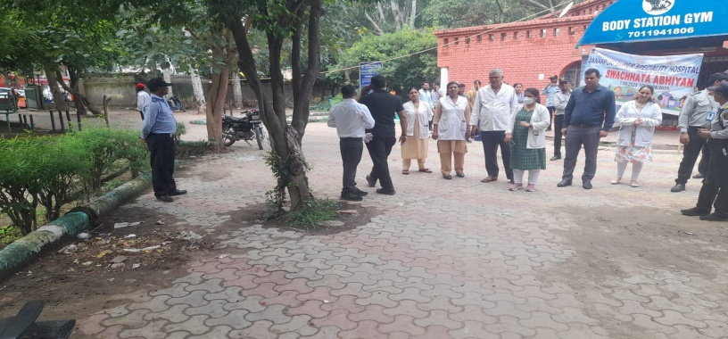 | 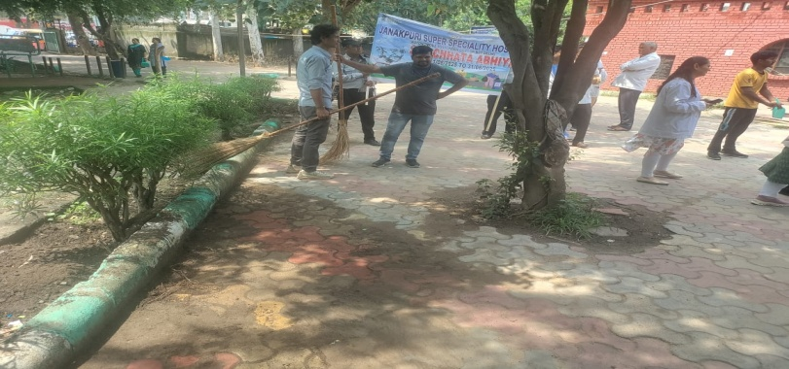
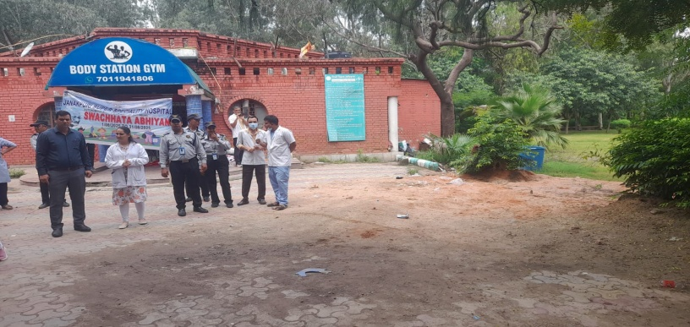 | 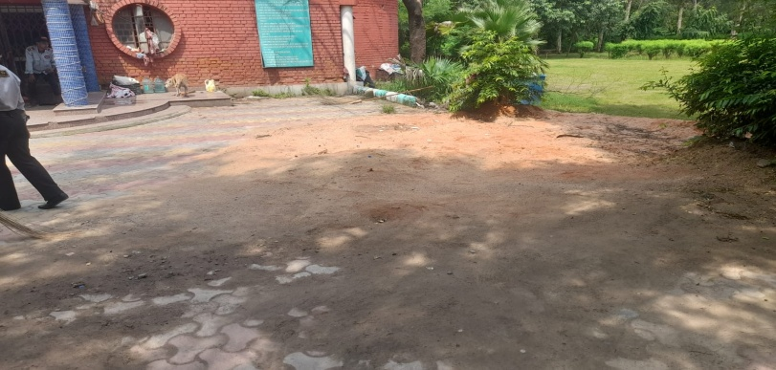
Details (50-100 words) –

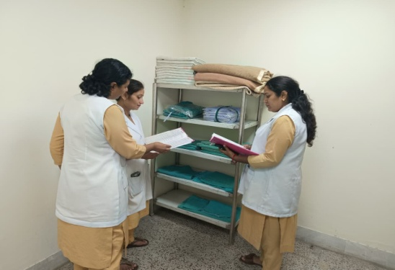 | 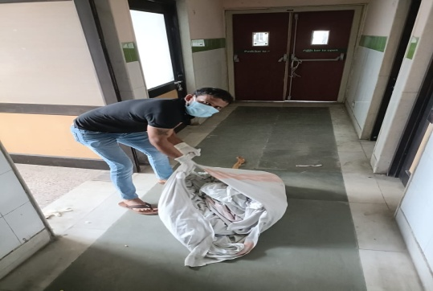 | 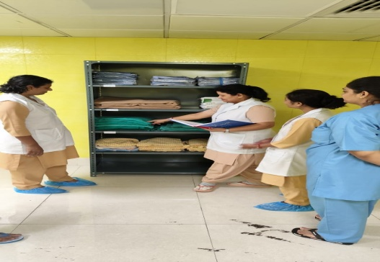
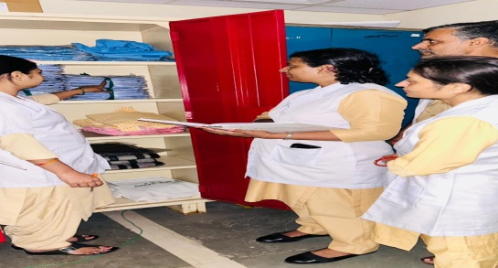 | 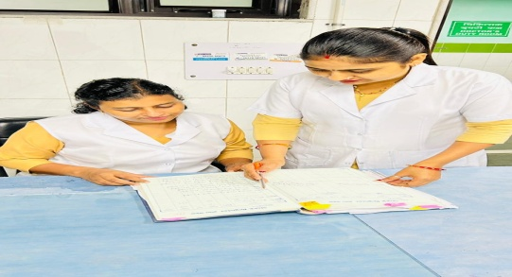 | 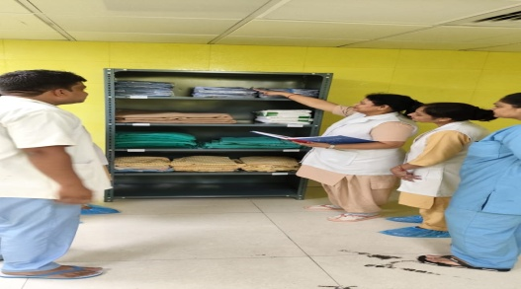

Remarks – Photograph of the activity should also be labeled for identification of activity. Dr. Shiv Shankar Prasad Singh
Addl. M.S.
JSSH

