REPORT FORMAT-A
Report of “दिल्ली को कूड़े से आज़ादी – Swacchata Campaign”
Conducted from 01.08.2025 – 31.08.2025
Name of the Institution
Janakpuri Super Specialty Hospital
Date -
25.08.2025
Activity conducted –
Food Safety & Kitchen Sanitation

A cleaning drive was conducted in the indoor kitchen area of the hospital. The open area of the kitchen was found not up to the mark hence a cleaning drive was also conducted at that place. The food quality and the document related to that was checked and found up to date. The relevant photos are enclosed herewith.
Before | After
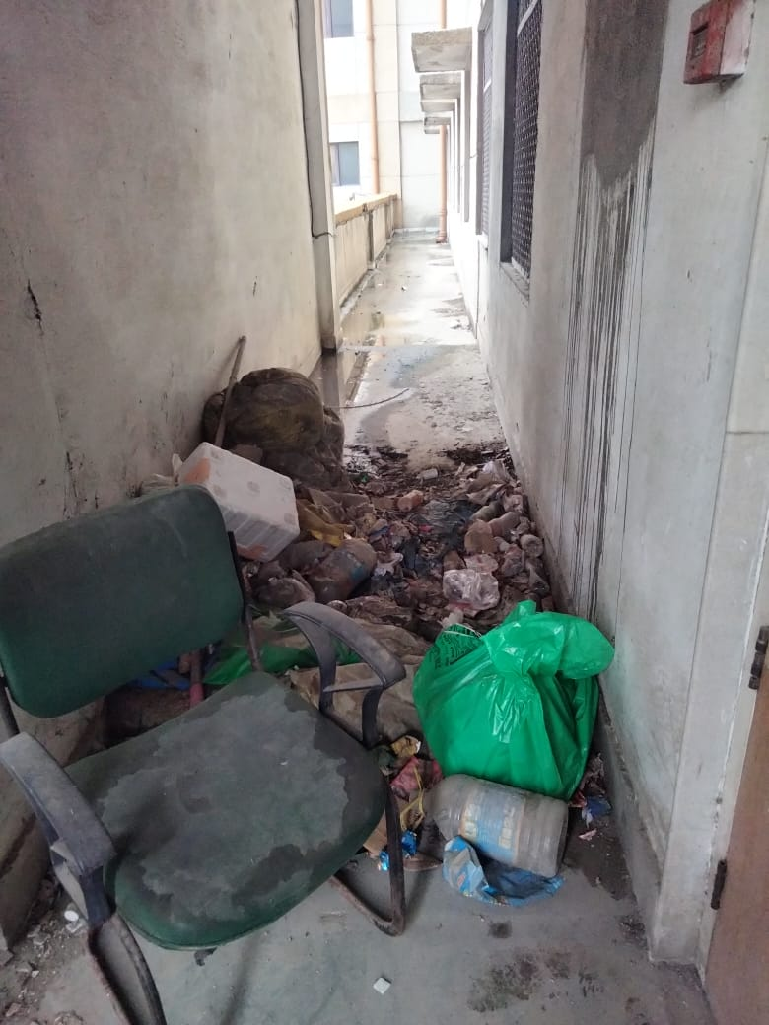 | 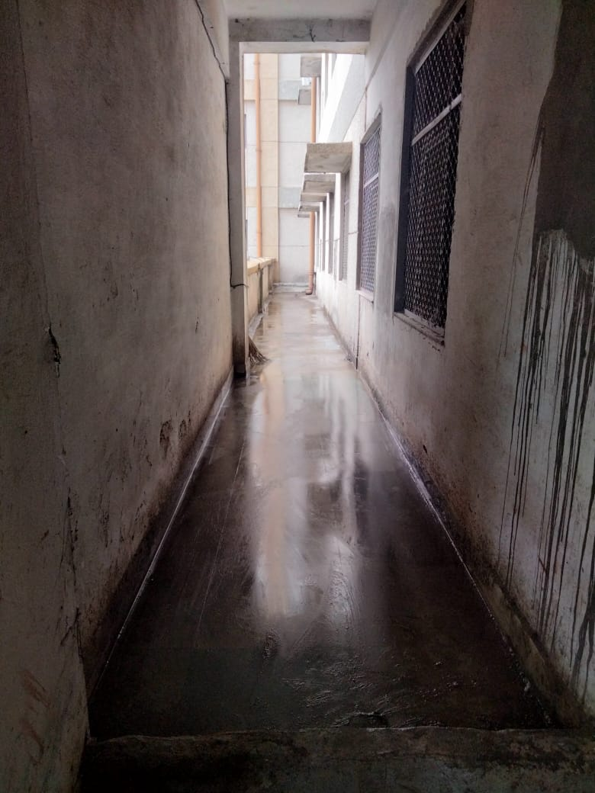
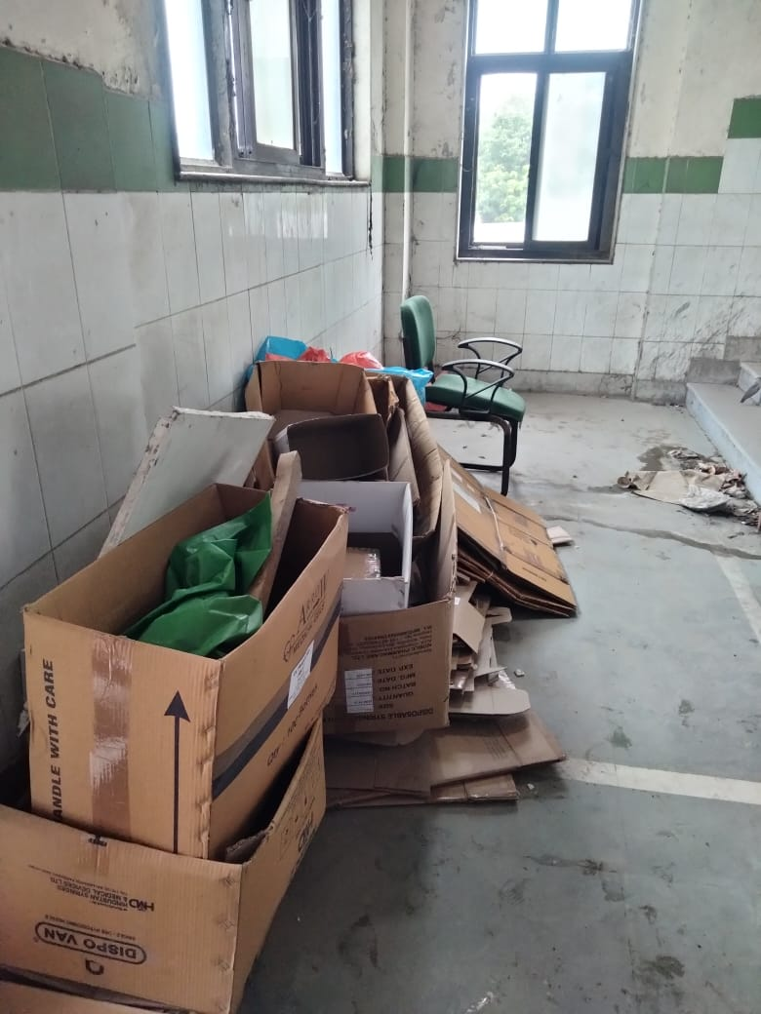 | 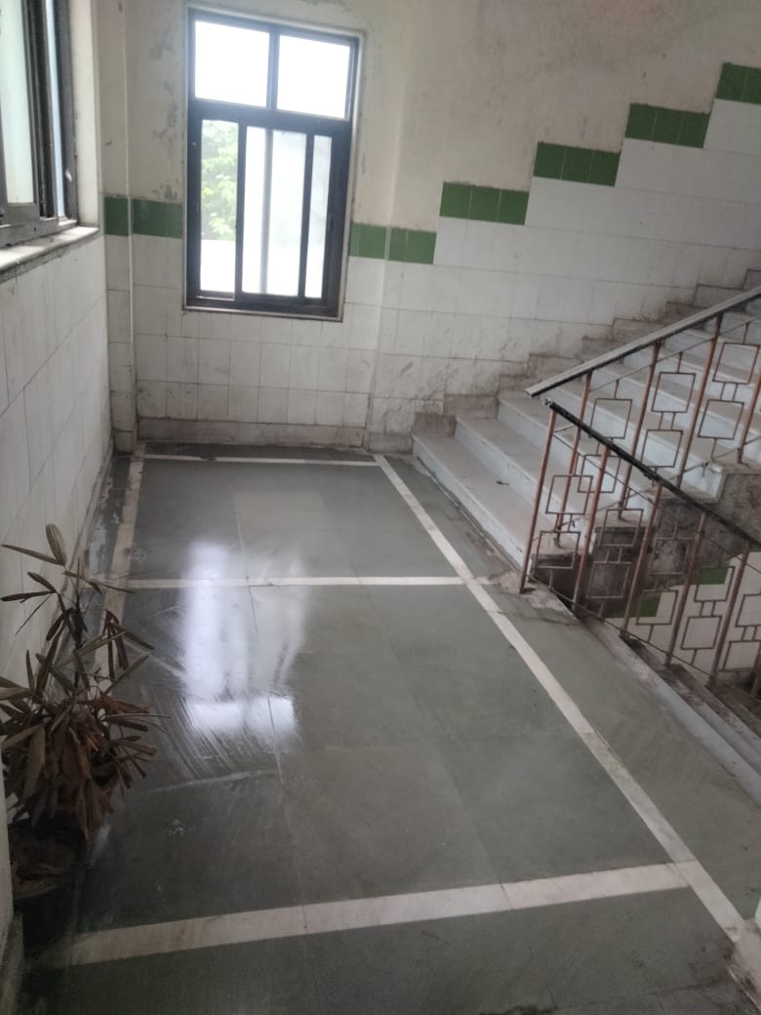
Details (50-100 words) –

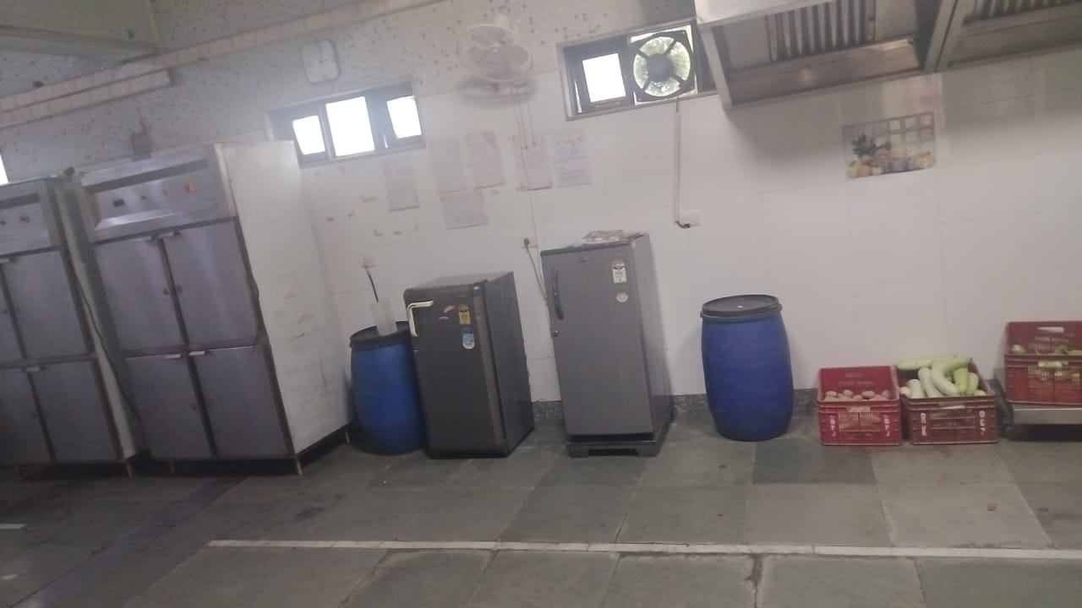 | 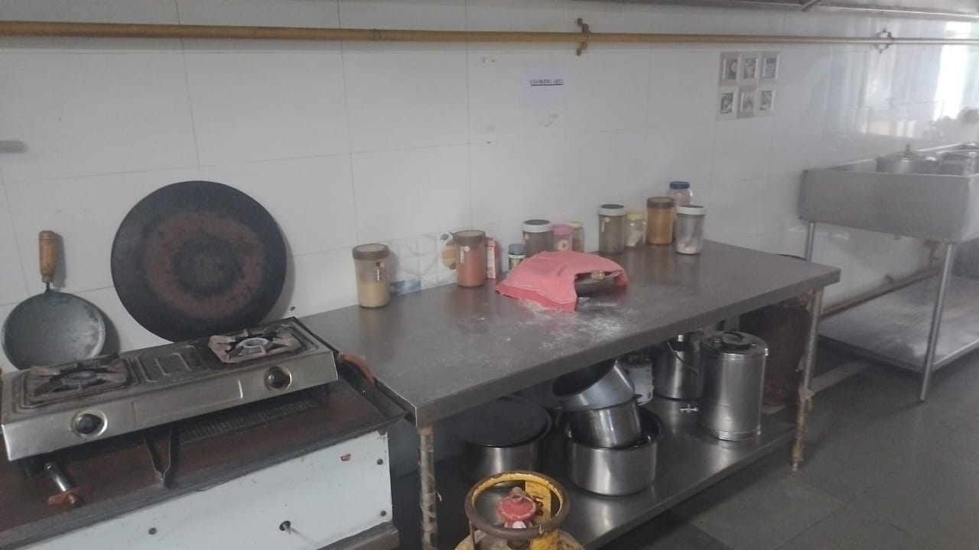

Remarks – Photograph of the activity should also be labeled for identification of activity. Dr. Shiv Shankar Prasad Singh
Addl. M.S.
JSSH

