REPORT FORMAT-A
Report of “दिल्ली को कूड़े से आज़ादी – Swacchata Campaign”
Conducted from 01.08.2025 – 31.08.2025
Name of the Institution
Janakpuri Super Specialty Hospital
Date -
26.08.2025
Activity conducted –
Pest Control Documentation

The pest control is doing at regular interval in various department of the hospital. The proper record is also maintained by the Care taking Branch of the hospital. The relevant photos are enclosed herewith.
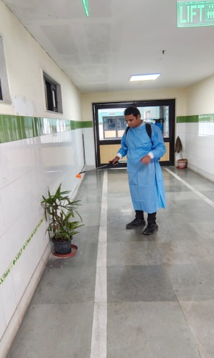 | 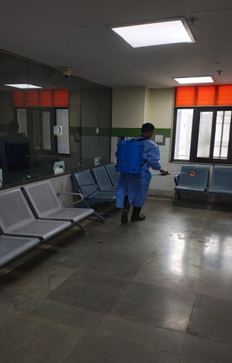 | 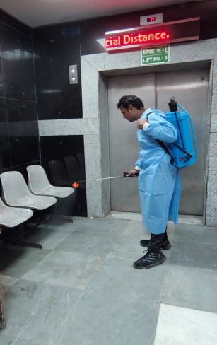 | 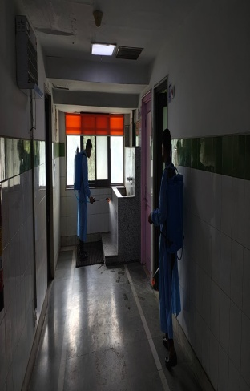 | 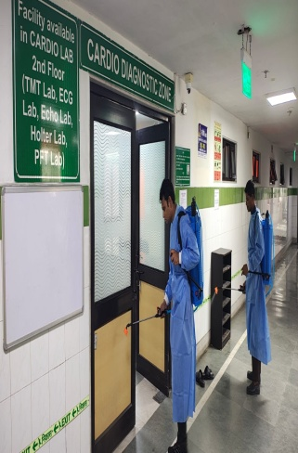
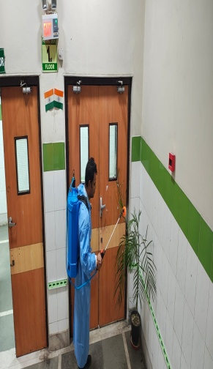 | 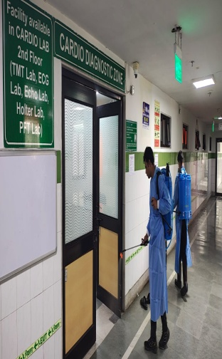 | 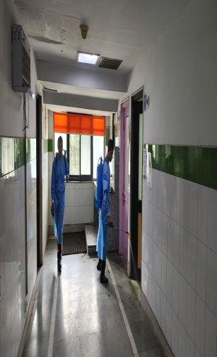 | 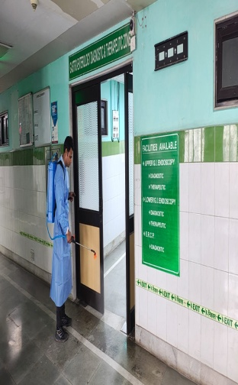 | 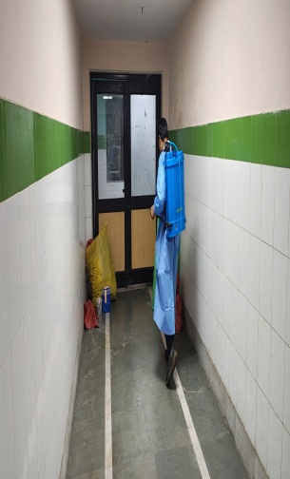
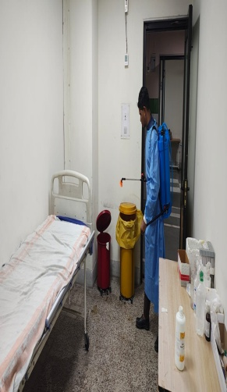 | 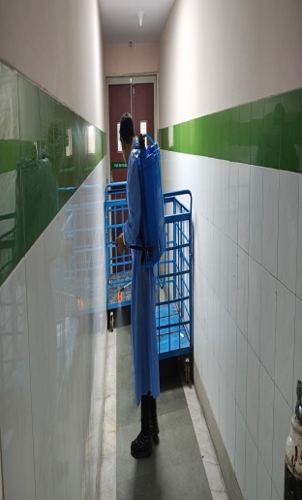 | 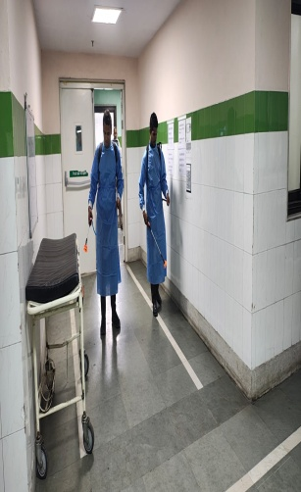 | 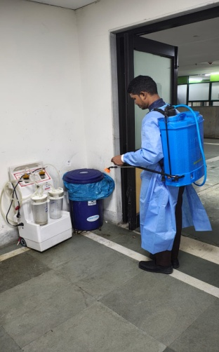 | 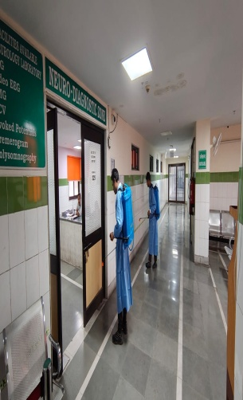
Details (50-100 words) –

Remarks – Photograph of the activity should also be labeled for identification of activity. Dr. Shiv Shankar Prasad Singh
Addl. M.S.
JSSH

