REPORT FORMAT-A
Report of “दिल्ली को कूड़े से आज़ादी – Swacchata Campaign”
Conducted from 01.08.2025 – 31.08.2025
Name of the Institution
Janakpuri Super Specialty Hospital
04.08.2025
Date
Weeding out of old documents, Cleanliness of MRD and Training on hand hygiene
Activity conducted –
Settled down the old records in the MRD. The cleanliness drive conducted at the MRD of the hospital. The before and after photos are enclosed herewith. The training was conducted on seven steps of hand hygiene in the conference room of JSSH.
Details (50-100 words) –

Before | After
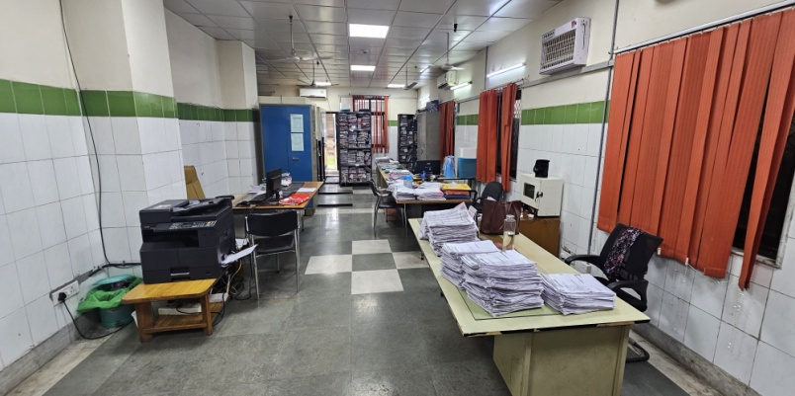 | 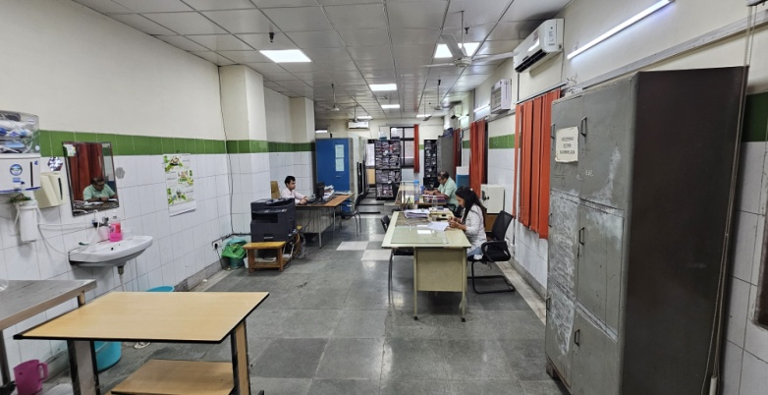
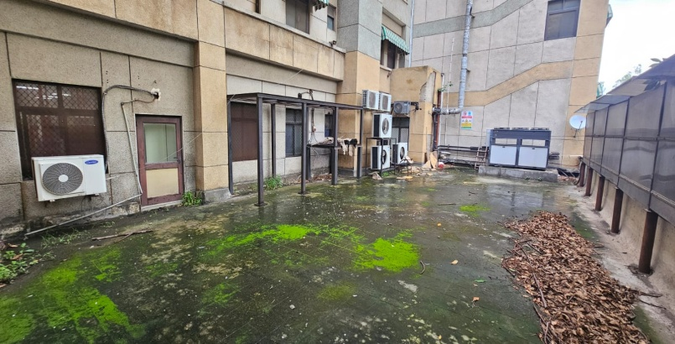 | 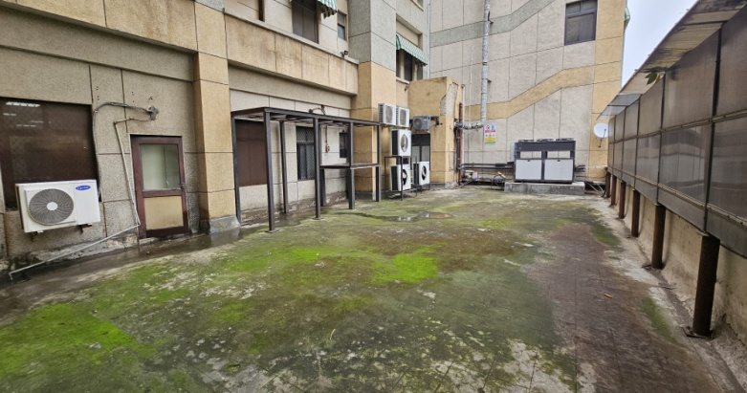
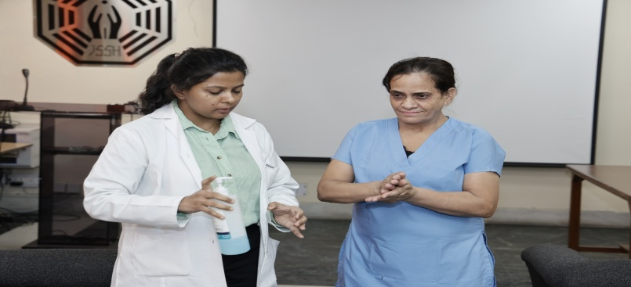 | 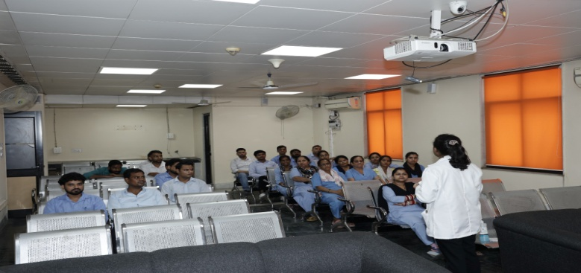
Remarks – Photograph of the activity should also be labeled for identification of activity.
Dr. Shiv Shankar Prasad Singh
Addl. M.S.
JSSH

