REPORT FORMAT-A
Report of “दिल्ली को कूड़े से आज़ादी – Swacchata Campaign”
Conducted from 01.08.2025 – 31.08.2025
Name of the Institution
Janakpuri Super Specialty Hospital
Date -
05.08.2025
Clean Linen, Kitchen Area & CSSD
Activity conducted -
The cleanliness drive conducted at the Kitchen Area, CSSD and Linen of the hospital. The before and after photos are enclosed herewith. The linen were arranged properly and entry gate was make clean, the photos of the same are also enclosed.
Details (50-100 words) –

Before | After
CSSD
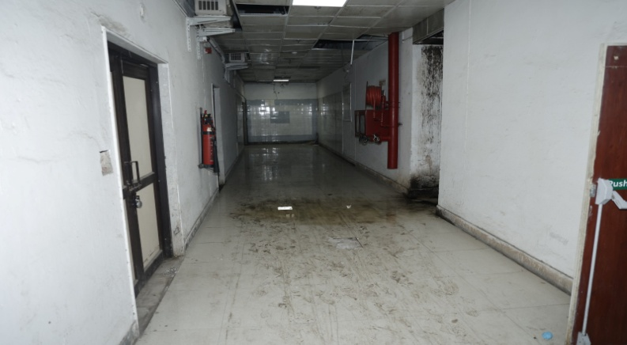 | 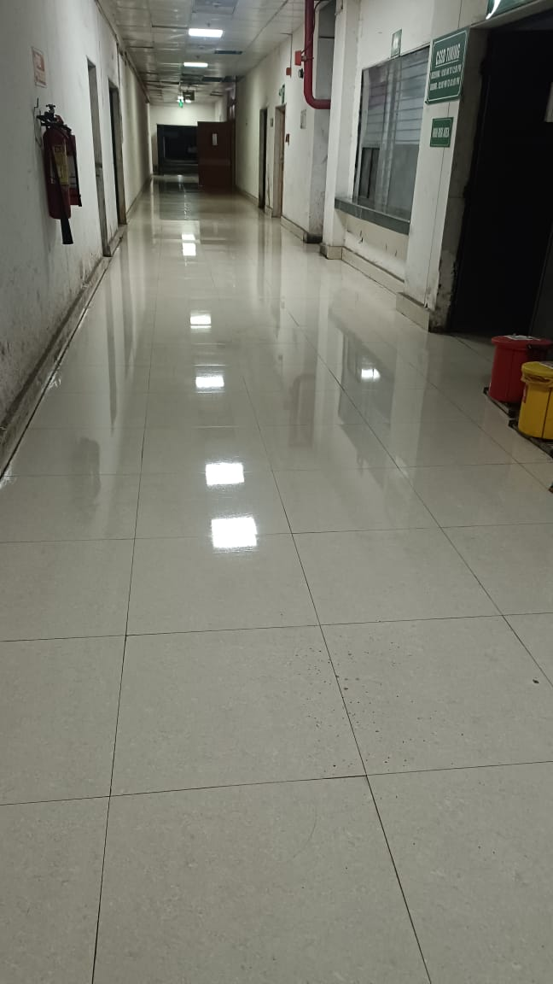
Kitchen
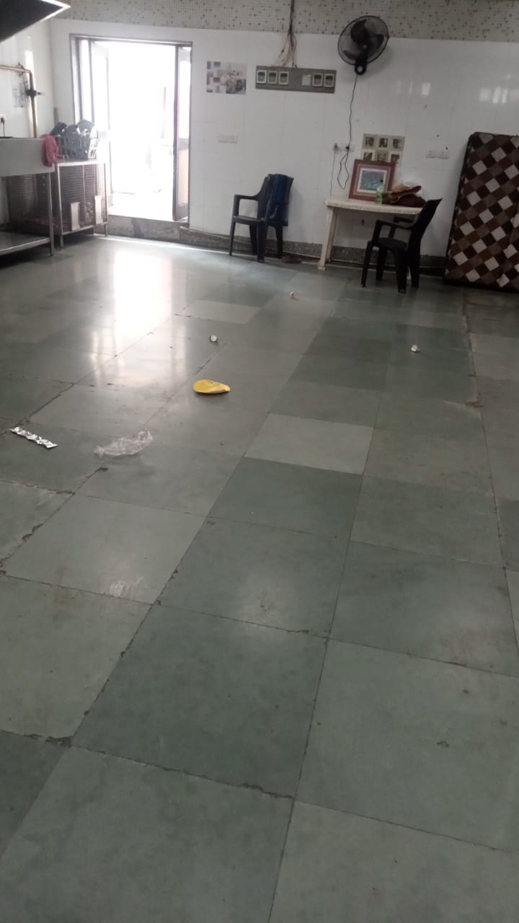 | 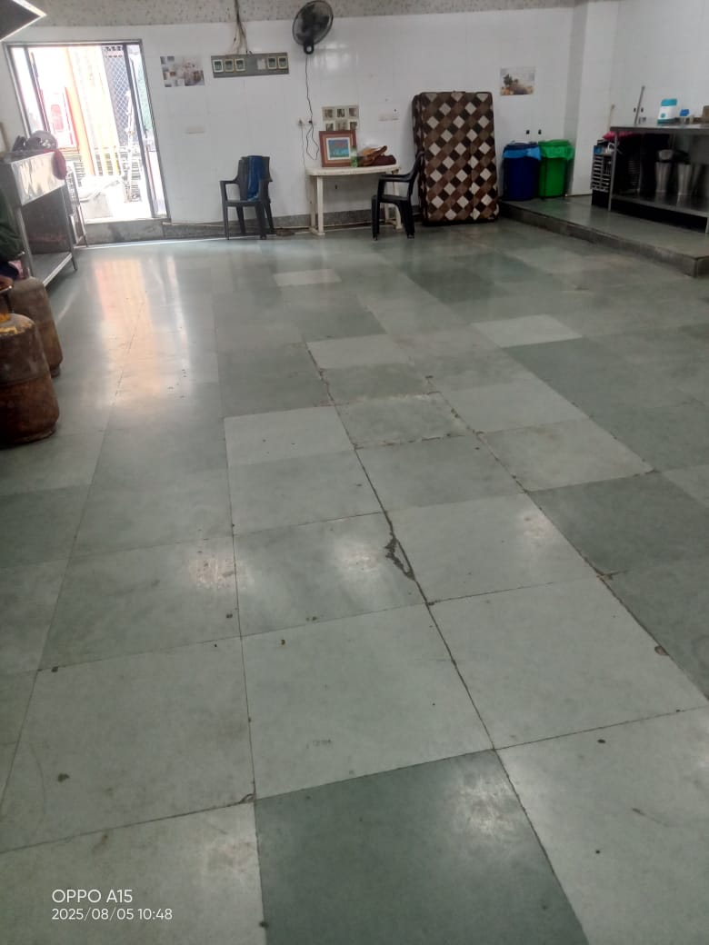

Linen | Entry Gate
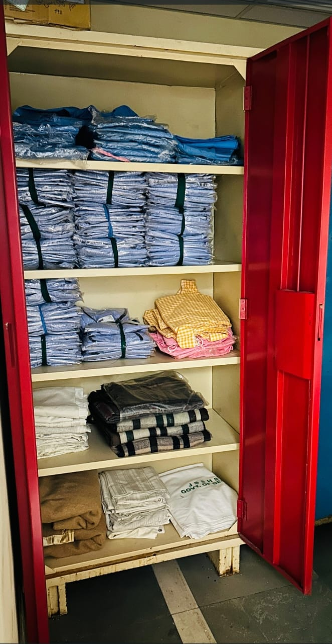 | 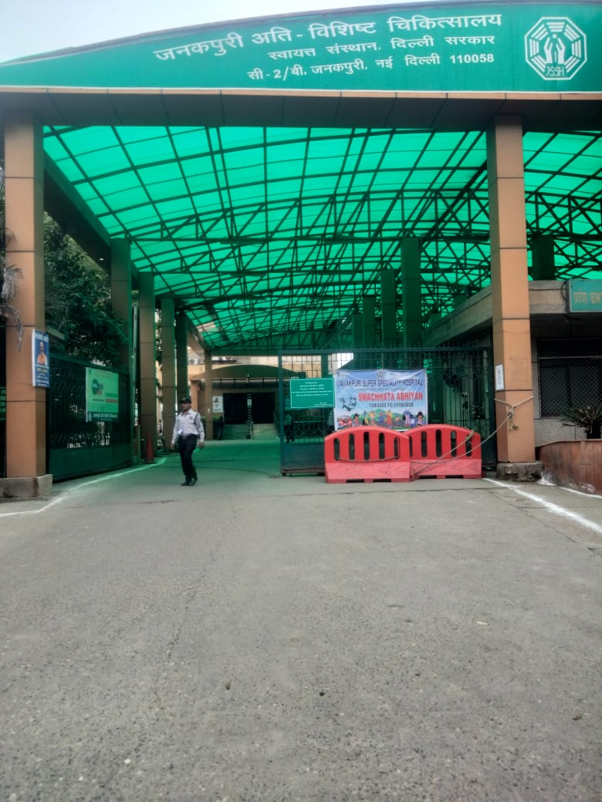
Remarks – Photograph of the activity should also be labeled for identification of activity. Dr. Shiv Shankar Prasad Singh
Addl. M.S.
JSSH

