REPORT FORMAT-A
Report of “दिल्ली को कूड़े से आज़ादी – Swacchata Campaign”
Conducted from 01.08.2025 – 31.08.2025
Name of the Institution
Janakpuri Super Specialty Hospital
Date -
07.08.2025
Activity conducted -
Water Sanitation Quality Review
A drive was conducted dedicated to cleaning of water tank, water outlets, servicing of installed RO system, measurement of TDS of water and water testing. The relevant photos are enclosed herewith.
Details (50-100 words) –

Before | After
Tank Cleaning
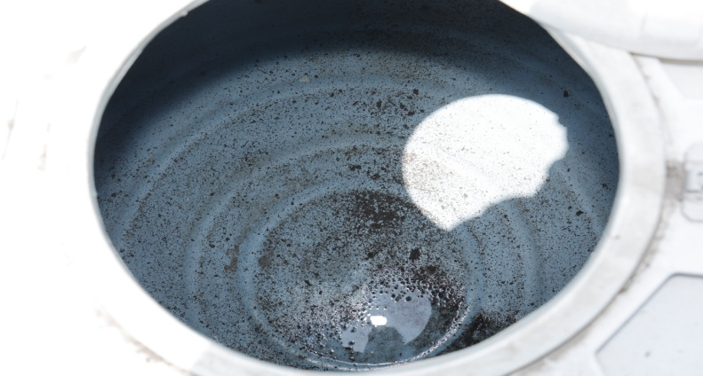 | 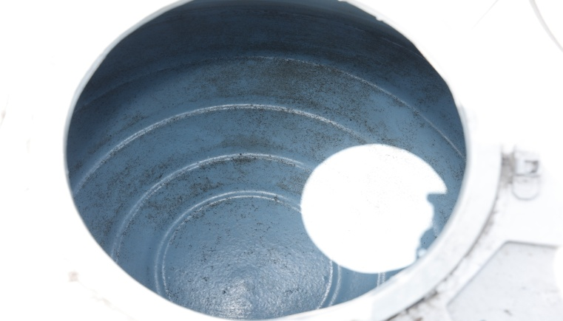

RO Maintenance
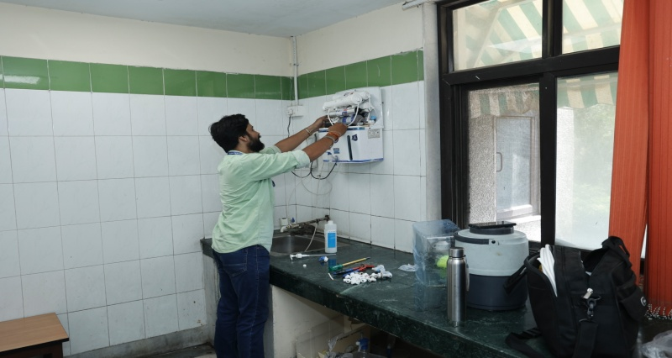 | 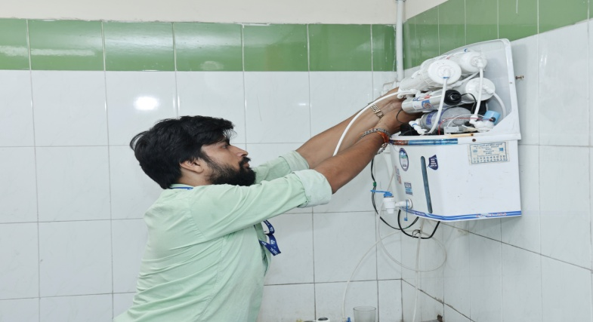

Water Testing
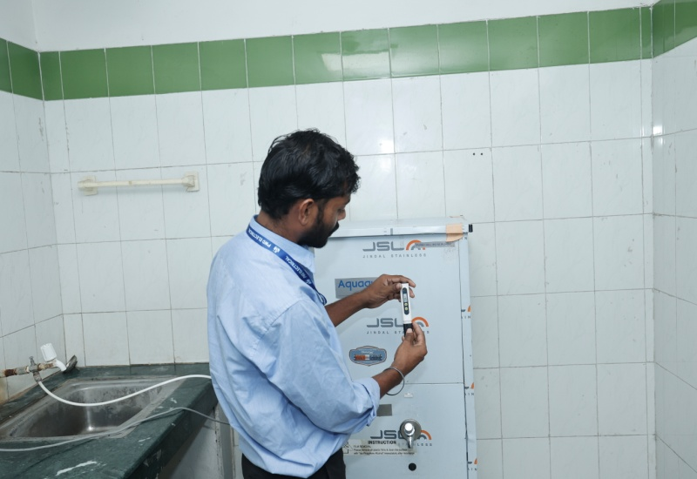 | 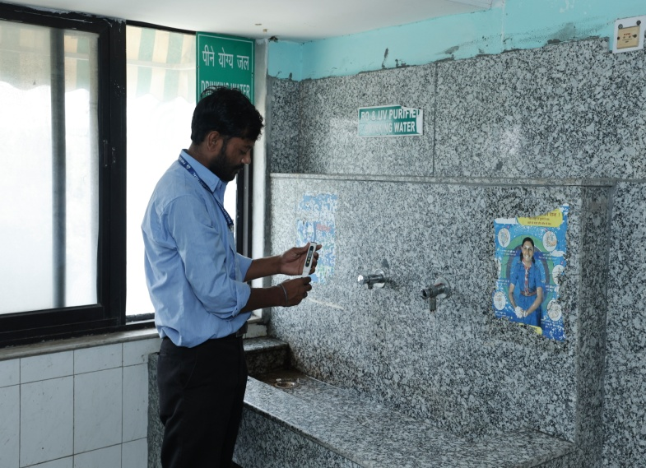
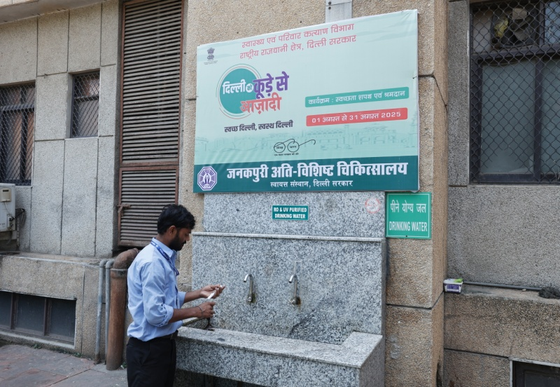 | 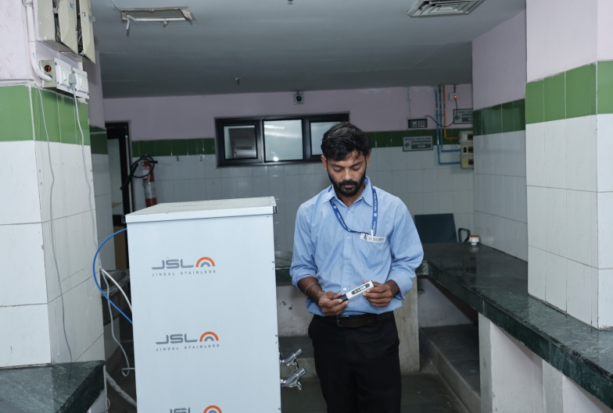

Remarks – Photograph of the activity should also be labeled for identification of activity. Dr. Shiv Shankar Prasad Singh
Addl. M.S.
JSSH

