REPORT FORMAT-A
Report of “दिल्ली को कूड़े से आज़ादी – Swacchata Campaign”
Conducted from 01.08.2025 – 31.08.2025
Name of the Institution
Janakpuri Super Specialty Hospital
Date -
08.08.2025
Activity conducted -
Condemnation Drive, Housekeeping staff training & Junk material audit
A round was taken in the 4th floor, 2nd floor, Store and the basement area. The items which were beyond the repair and lying unused in the hospital were enlisted and placed at a designated area in the basement for condemnation. A Class was organized for the housekeeping staff and other staff for training on PPE. The relevant photos are enclosed herewith.
Details (50-100 words) –

Before | After
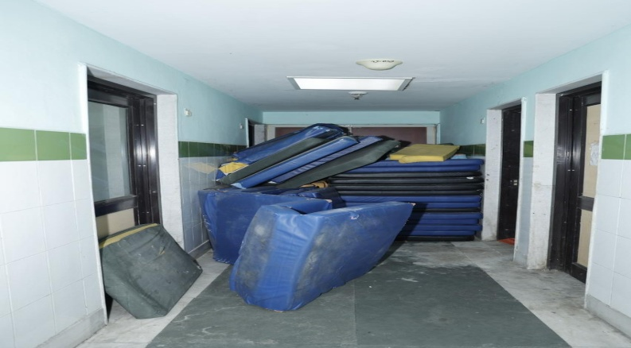 | 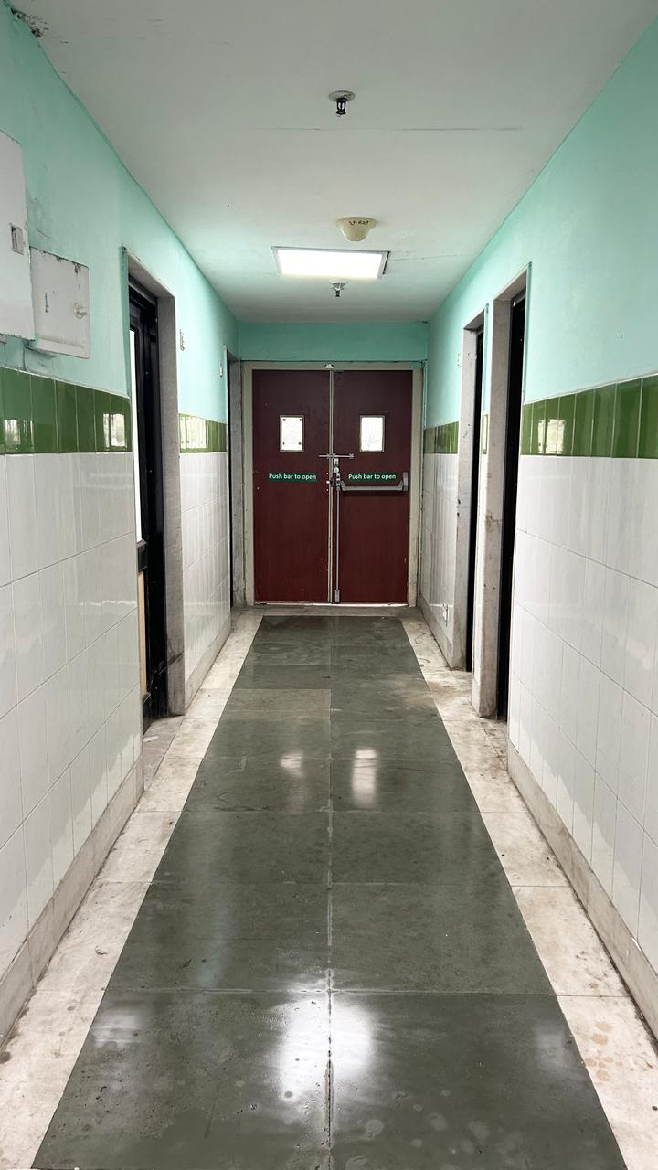
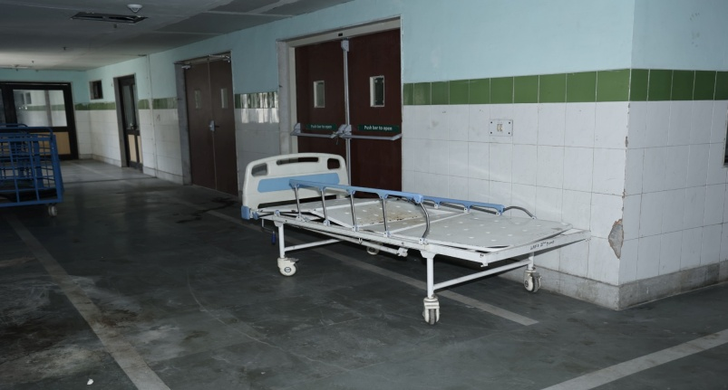 | 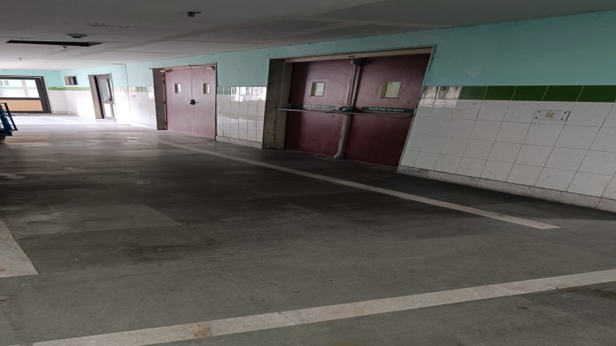

Training of staff on SOP & PPE uses
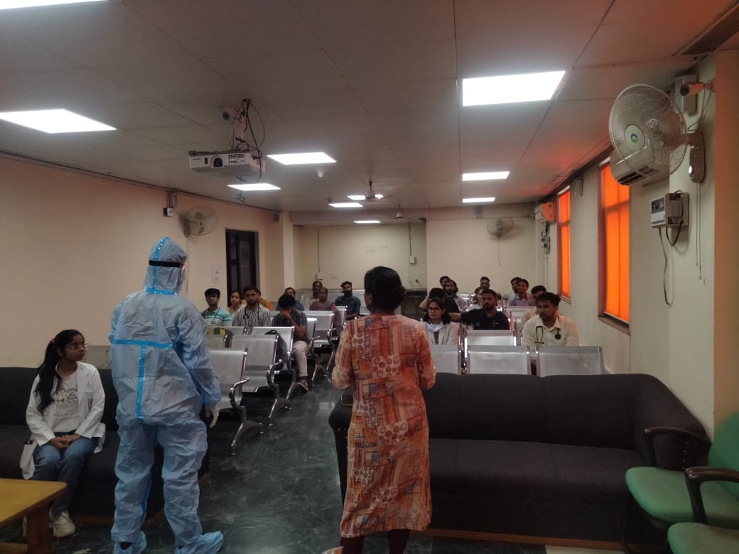 | 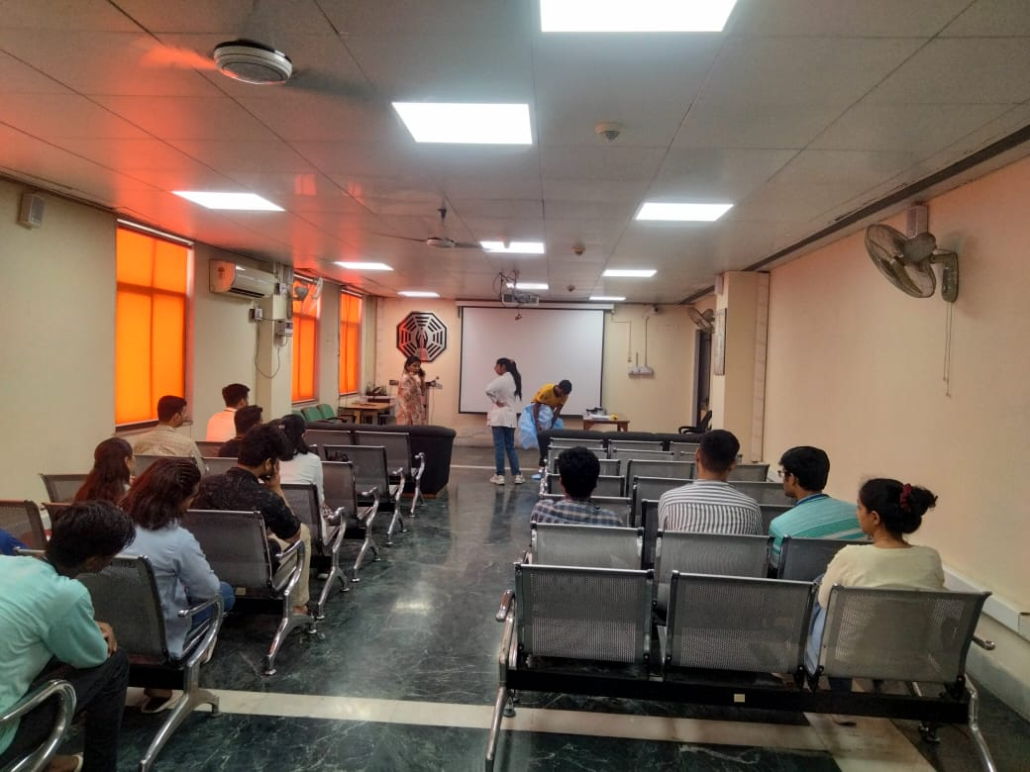
Remarks – Photograph of the activity should also be labeled for identification of activity. Dr. Shiv Shankar Prasad Singh
Addl. M.S.
JSSH

