REPORT FORMAT-A
Report of “दिल्ली को कूड़े से आज़ादी – Swacchata Campaign”
Conducted from 01.08.2025 – 31.08.2025
Name of the Institution
Janakpuri Super Specialty Hospital
Date -
02.09.2025
Activity conducted –
Cleaning of Pharmacy Area

A cleaning drive was conducted near pharmacy area and female guard room. Relevant photos are attached herewith.
Details (50-100 words) –

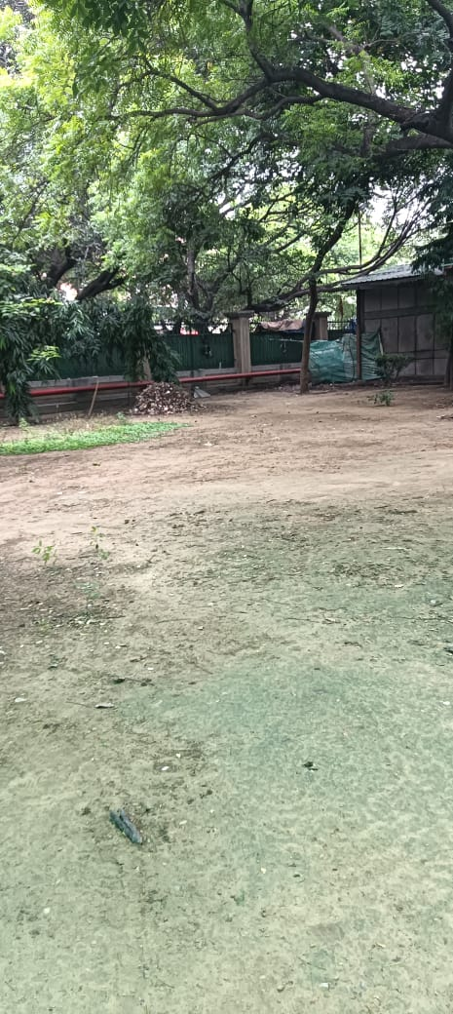 | 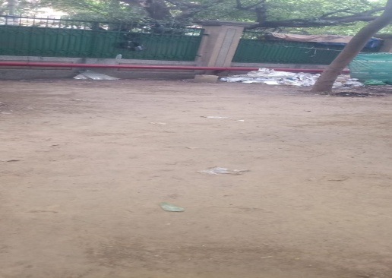 | 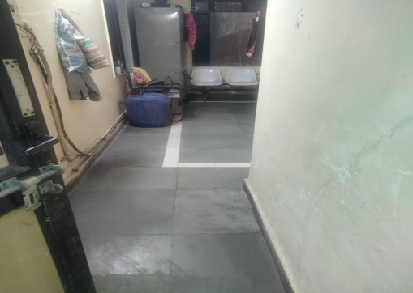
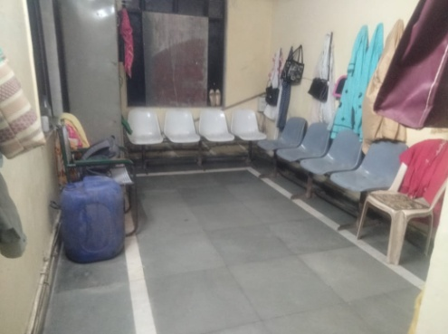 | 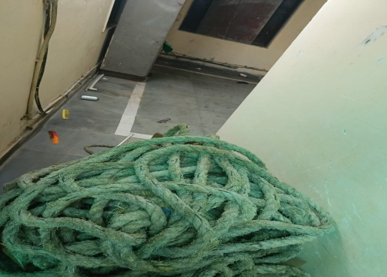 | 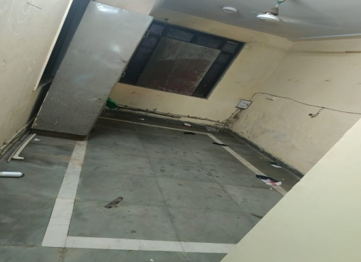
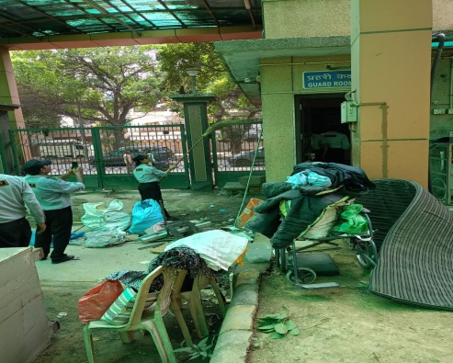 | 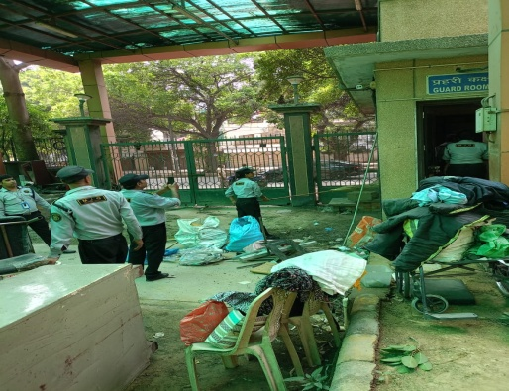 | 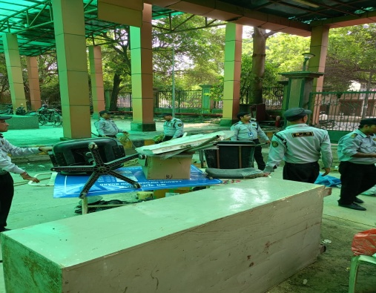

Remarks – Photograph of the activity should also be labeled for identification of activity. Dr. Shiv Shankar Prasad Singh
Addl. M.S.
JSSH

